**St. Francis Institute of Technology Borivli (West), Mumbai-400103**

**(Autonomous Institute)**

**Department of Information Technology**

**Sub: Internet Programming**

**Experiment -6: Design of React Single Page Application**

**1. Aim:** To design a single page application in react using react router.

**2. Objective:** To understand and design front end applications using react

**3. Lab Outcome:** Students will be able to construct front end applications using React (PO3, PO5, PSO3, PSO4)

**4. Prerequisite:** HTML, CSS, node.js, react

**5. Requirements:** The following are the requirements **–**

• PC/Laptop

• Visual Studio Code

• Browser

**6. Pre-Experiment Theory:**

React Components are independent and reusable bits of code. They serve the same purpose as JavaScript functions, but work in isolation and return HTML.

Components come in two types –

• Class components - A class component must include the extends React.Component statement. This statement creates an inheritance to React.Component, and gives your component access to React.Component's functions. The component also requires a render() method, this method returns HTML.

• Function components - A Function component also returns HTML, and behaves much the same way as a Class component, but Function components can be written using much less code, are easier to understand.

Components can be passed as props, which stands for properties. Props are like function arguments, and you send them into the component as attributes.

We can refer to components inside other components.

React is all about re-using code, and it is recommended to split your components into separate files. To do that, create a new file with a .js file extension and put the code inside it. Create React App doesn't include page routing. React Router is the most popular solution. React Router is a standard library for routing in React. It enables the navigation among views of various components in a React Application, allows changing the browser URL, and keeps the UI in sync with the URL.

React Router can be installed via npm in your React application. After installing react-router dom, add its components to your React application.

The main Components of React Router are:

• BrowserRouter - BrowserRouter is a router implementation that uses the HTML5

**1 |Internet Programming Lab**

history API (pushState, replaceState and the popstate event) to keep your UI in sync with the URL. It is the parent component that is used to store all of the other components.

• Route - Route is the conditionally shown component that renders some UI when its path matches the current URL.

• Link - Link component is used to create links to different routes and implement navigation around the application. It works like HTML anchor tag.

• Switch - Switch component is used to render only the first route that matches the location rather than rendering all matching routes. Although there is no defying functionality of SWITCH tag in our application because none of the LINK paths are ever going to coincide. But let’s say we have a route (Note that there is no EXACT in here), then all the Route tags are going to be processed which start with ‘/’ (all Routes start with /). This is where we need SWITCH statement to process only one of the statements.

**7. Laboratory Exercise:**

**A. Procedure**

• Add following extensions in vs code (Recommended) – Babel JavaScript, JavaScript ES6 Code Snippets, vs code icons

• Install node.js (npm installs automatically)

• Open terminal window (use cmd command)

• Check version of node.js (node -v)

• Check version of npm (npm -v)

• Install react from terminal using following commands -

• npm install -g create-react-app

• create-react-app –version

• d:

• mkdir <foldername>

• cd <foldername>

• create-react-app <projname> (may take a few minutes)

• cd <projname>

• npm start (localhost:3000 – react app installed in local system)

• Open vs-code and open the folder.

• Write your code

To view the output, reload the react app

Check output

**B. Program Code**

Design a single page application in react using react router using the suggestive guidelines as mentioned below. However, you are free to include other features covered earlier to make the design more feature rich.

**2 |Internet Programming Lab**

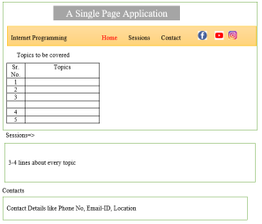

**8. Post Experimental Exercise**

1) What is HashRouter in react?

2) Differentiate between HashRouter and BrowserRouter.

3) Explain the use of basename, window and future properties in HashRouter with the help of an example.

**9. Results/Observations/Program output:**

Present the program code and output

**10. Conclusion:**

Write what was performed in the experiment

Write which all features of HTML, CSS and React you used to perform the experiment

**11. References:**

• https://nodejs.org/en/

• https://www.thapatechnical.com/2020/05/install-reactjs-windows-install-nodejs.html • https://www.kirupa.com/react/setting_up_react_environment.htm

• https://www.kirupa.com/react/creating_single_page_app_react_using_react_router.htm • https://youtu.be/tg73NsiQOUE

• <https://www.youtube.com/watch?v=8AJ3Kcz5Fs>

**3 |Internet Programming Lab**

1. **CREATION OF A REACT APP:**

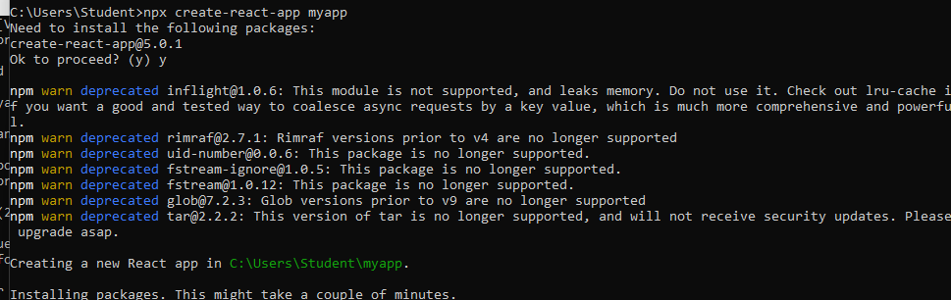

1. **INSTALLATION OF ROUTE** 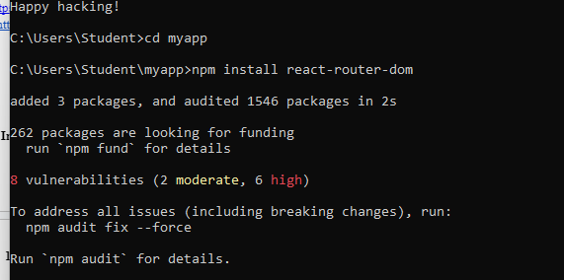
2. **START THE SERVER:**

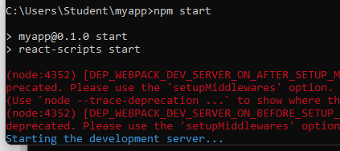

1. **INSTALL LIBRARIES:**

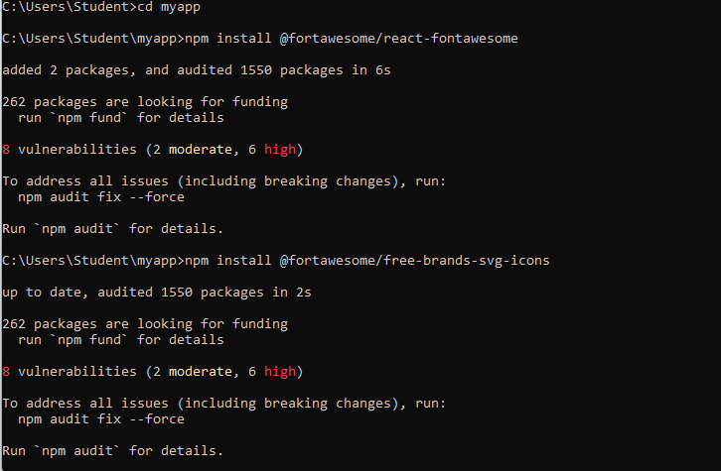

**APP. JS CODE:**

import React from 'react';

function Home() {

return (

<div>

<h4>Topics to be covered</h4>

<table border="1" className="topics-table">

<thead>

<tr>

<th>Sr. No.</th>

<th>Topics</th>

</tr>

</thead>

<tbody>

<tr>

<td>1</td>

<td>Introduction to Web Architecture</td>

</tr>

<tr>

<td>2</td>

<td>Front-End Libraries</td>

</tr>

<tr>

<td>3</td>

<td>Version Control Systems</td>

</tr>

<tr>

<td>5</td>

<td>Web Performance Optimization</td>

</tr>

</tbody>

</table>

</div>

);

}

export default Home;

**HOME.JS**

import React from 'react';

function Home() {

return (

<div>

<h4>Topics to be covered</h4>

<table border="1" className="topics-table">

<thead>

<tr>

<th>Sr. No.</th>

<th>Topics</th>

</tr>

</thead>

<tbody>

<tr>

<td>1</td>

<td>Introduction to Web Architecture</td>

</tr>

<tr>

<td>2</td>

<td>Front-End Libraries</td>

</tr>

<tr>

<td>4</td>

<td>Databases and Storage</td>

</tr>

<tr>

<td>5</td>

<td>Web Performance Optimization</td>

</tr>

</tbody>

</table>

</div>

);

}

export default Home;

**SESSIONS.JS**

import React from 'react';

function Sessions() {

return (

<div className='deets'>

<h4>Sessions</h4>

<p><strong>1. Introduction to Web Architecture</strong>: Understand the interaction between clients and servers.</p>

<p><strong>2. Front-End Libraries</strong>: Learn how to use libraries for designing visually appealing websites.</p>

<p><strong>3. Version Control Systems</strong>: Explore GitHub to collaborate with other developers.</p>

</div>

);

}

export default Sessions;

**CONTACT.JS**

**import React from 'react';**

**function Contact() {**

**return (**

**<div>**

**<h4>Contact</h4>**

**<p><strong>Phone No:</strong> 8828174914</p>**

**<p><strong>Email-ID:</strong> durvakadam204@student.sfit.ac.in</p>**

**<p><strong>Location:</strong> Borivali(E), Mumbai 400066</p>**

**</div>**

**);**

**export default Contact;**

**INTERFACES:**

HOME PAGE:

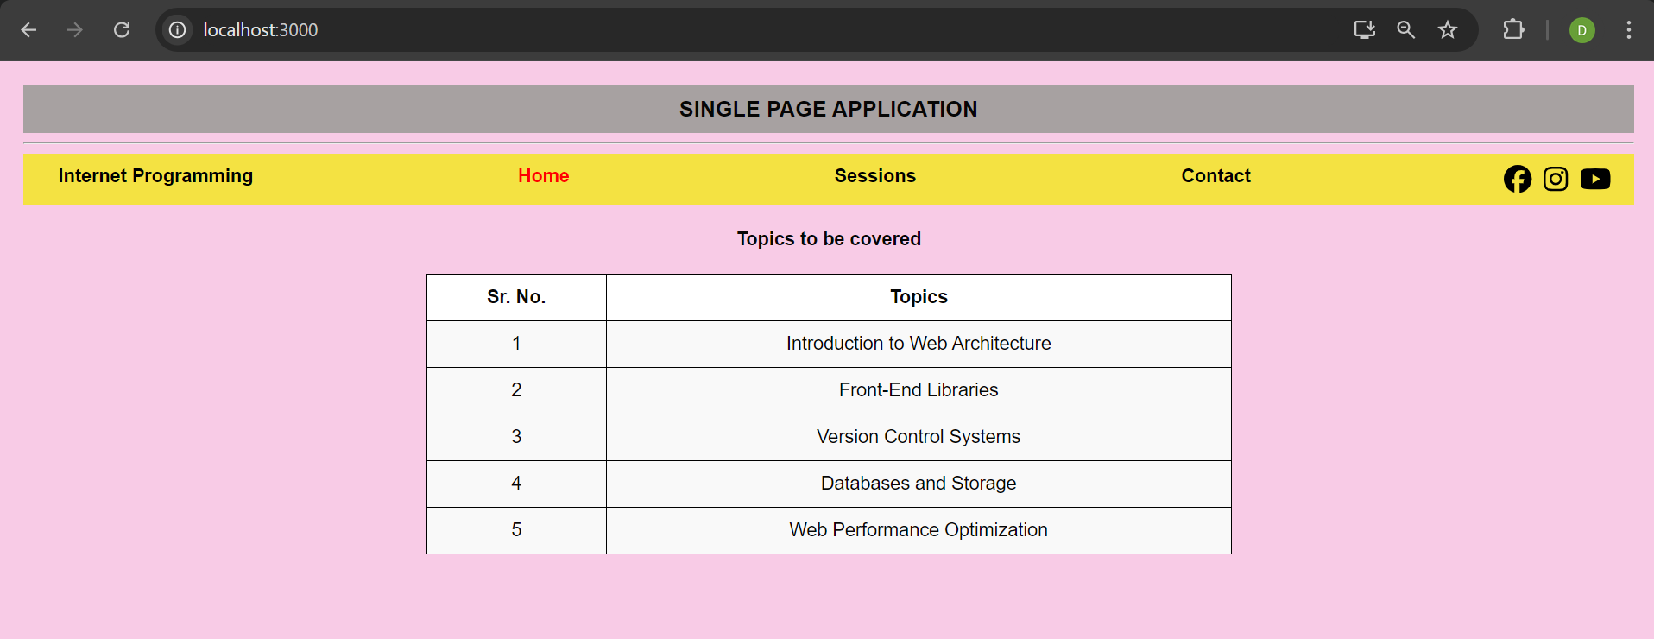

SESSIONS PAGE:

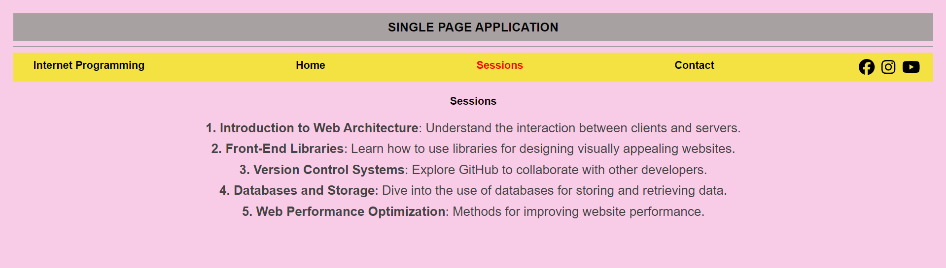

CONTACT PAGE:

